Session:

2021

-

2022



**MINI PROJECT REPORT**

**On**

**“CAKE BAKERY”**

**BACHELOR OF TECHNOLOGY IN COMPUTER**

**SCIENCE AND ENGINEERING**

**Submitted to-**

**Mr. Ankush Gupta**

## (Department of Computer Science & Engineering)

**Submitted by-**

**Student name: Roll No. -**

**Nishita Sharma 2000680100205**

**3RD SEMESTER**

**DEPARTMENT OF COMPUTER SCIENCE AND ENGINEERING MEERUT INSTITUTE OF ENGINEERING AND TECHNOLOGY, MEERUT**

**DECLARATION**

We hereby declare that the project entitled - “**CAKE BAKERY**”, which is being submitted as Mini Project in department of Computer Science and engineering to Meerut Institute of Engineering and Technology, Meerut (U.P.) is an authentic record of our genuine work done under the guidance of Mr. Ankush Gupta of Computer Science and Engineering, Meerut Institute of Engineering and Technology, Meerut.

|  |  |
| --- | --- |
| Date: |  |
| Place: |  |

Name of student: Nishita Sharma

Roll no. 2000680100205

**CERTIFICATE**

This is to certify that mini project report entitled – “**CAKE BAKERY**” submitted by Nishita Sharma has been carried out under the guidance of Mr. Ankush Gupta of Computer Science and Engineering, Meerut Institute of Engineering and Technology, Meerut. This project report is approved for Mini Project (KCN-354) in 3rd semester in “department name” from Meerut Institute of Engineering and Technology, Meerut.

**Internal Examiner :**

**Date:**

.

# 

# ACKNOWLEDGEMENT

I express my sincere indebtedness towards our guide Mr. Ankush Gupta, of Computer Science and Engineering, Meerut Institute of Engineering and Technology, Meerut for his valuable suggestion, guidance and supervision throughout the work. Without his king patronage and guidance of the project would not have taken shape. I would also like to express my gratitude and sincere regards for his kind approval of the project. Time to time counselling and advises.

I would also like to thank to our HoD Dr. M.I.H Ansari, Department of Computer Science and engineering, Meerut Institute of Engineering and Technology, Meerut for his expert advice and counselling from time to time.

I owe sincere thanks to all the faculty members in the department of Computer Science and engineering for their kind guidance and encouragement time to time.

Date:

Student name: Nishita Sharma

### 

### Table of contents

**Description page no.**

Declaration 2

Certificate 3

Acknowledgement 4

**Chapter 1 Introduction**

**Chapter 2 System Design**

(Work flow/flow chart/DFD/ working principle/ constructional details of individual componenets)

**Chapter 3 Technology Bucket**

3.1 Description of HTML

3.3 Description of CSS

3.4 Description of Java Script

**Chapter 4** Output screens

**Appendices** Implementation code

**References**

**Chapter – 1**

**Introduction**

The website is on the topic - ‘CAKE BAKERY’. The website name is ‘BAKERS’S DELIGHT’, the website is about freshly and handcrafted made gourmet cakes for different occasions. The order can be made by selecting the cake and placing the order for it.

The website consists of index page, home page, about us page, cakes page and contact us page. Starting from the index page of the website. The index page contains information about the website and other four links which are mentioned below:

1. HOME

Clicking on ‘Home’ option you are able to see the home page of the website which contains other options as well. There is also information about the content of the website. You can visit the content of the site by clicking on the connected links.

1. About us

In this section you can see how the bakery initially started and can also have a glimpse about the history of it.

1. Cakes

The ‘Cakes’ section contains different types of cakes for various occasions. By viewing the different cakes you can select your favourite one and also place on order for it. You will get directed to the form, which you need to fill for placing an order.

1. Contact us

Contact us page contains a form and the route of the cake bakery shop. The form can be filled by those who have any query related or want any kind of customized cake for their events. There are various stores available across the nation, hence a general map is shown, you can simply click on the map and find your nearby store.

**Chapter 2**

**System Design**

1. Flowchart of the website
2. Flowchart for placing order

**Chapter 3**

**Technology Bucket**

**3.1) HTML**

Hyper Text Markup Language **(**HTML) is a type of markup language It is used to make webpages. Webpages can include writing, links, pictures, and even sound and video. HTML tells web browsers what webpages should look like. HTML also adds meta information to webpages. Meta information is information about a webpage e.g., the name of the person who created the page. Web browsers usually do not show meta information.

HTML is often used with cascading style sheet (CSS) and java script. CSS is used to change the way HTML looks. JavaScript tells websites how to behave. It can also change HTML and CSS.

* The <! DOCTYPE html> declaration defines this document to be HTML.
* The < html> tag encloses the complete html file and contains the header i.e. <head>…. </head> tag and the body tag i.e.

<body>…. </body>.

* The <head> tag contains the header of the file and also contains the <title>… </title> tag and the <style>... </style> tag of css.
* The <title> tag contains the title of the html file which shows in the header of the browser.
* The <body> tag contains all the contents of an html document such as headings, paragraphs, images, hyperlinks, tables, lists etc. F) The <h1> tag in html indicates a heading on a website. Html has six different heading tags – h1, h2, h3, h4, h5, h6.
* The <div> tag in html defines a division or a section in an html document.
* The <form> tag is used to create an html form for user input. I) The <input> tag is used to create interactive controls for web-based forms in order to accept data from the user.
* J) The <button> tag is used to create a clickable button within html form on your webpage.

**3.2) CSS**

* The CSS stands for Cascading Style Sheets and it is used for describing the presentation of a document written in a markup language like html.
* The background-image property is used for set the image in the background.

Syntax: body {background-image: url (‘file name’);}

* In the CSS, a class selector is a name preceded by a full stop (“.”) and an ID selector is a name preceded by a hash character (“#”).
* ID is used to identify one element and class is used to identify more than one element.
* Margin and padding are the two most commonly used properties for spacing out elements. Margin is the space outside something and padding is the space inside something.
* The: hover selector is used to change the style of a button when you move mouse over them.
* The border radius property defines the radius of the element’s corners. This property allows you to add rounded corners to elements.

**3.3) JAVASCRIPT**

* Alongside HTML and CSS, JAVASCRIPT is one of the core technologies of the World Wide Web.
* JavaScript enables interactive web pages and is an essential part of web applications.
* Validating input values of a web form to make sure that they are acceptable before being submitted to the server.
* Animation of page elements such as fading them in and out resizing and moving them.
* Interactive content, such as games and videos. Loading new page content without reloading the page.

**Chapter 4**

**OUTPUT SCREEN**

1. Index page

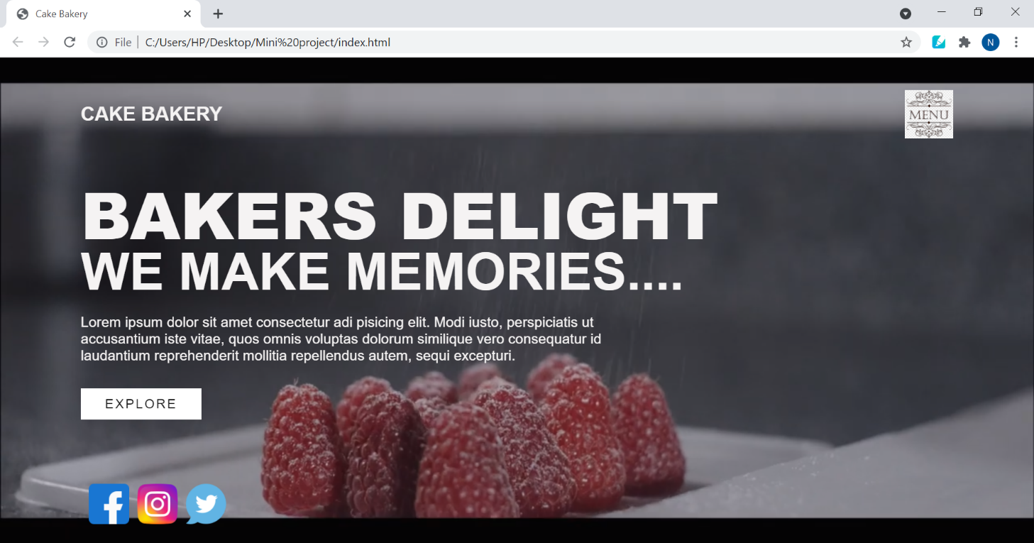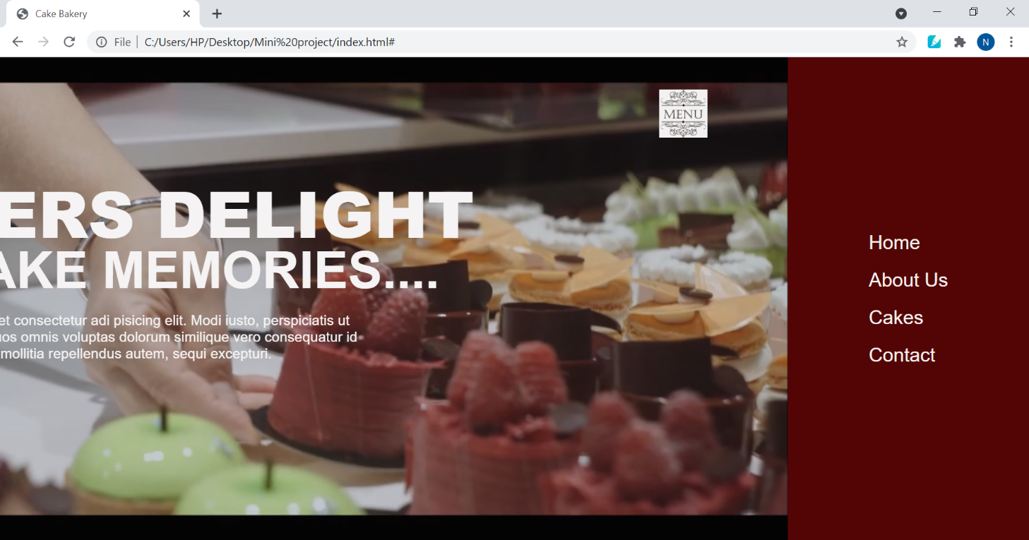

1. Home page

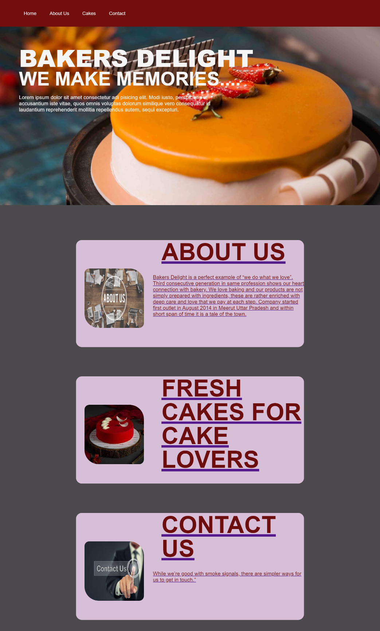

1. About Us page

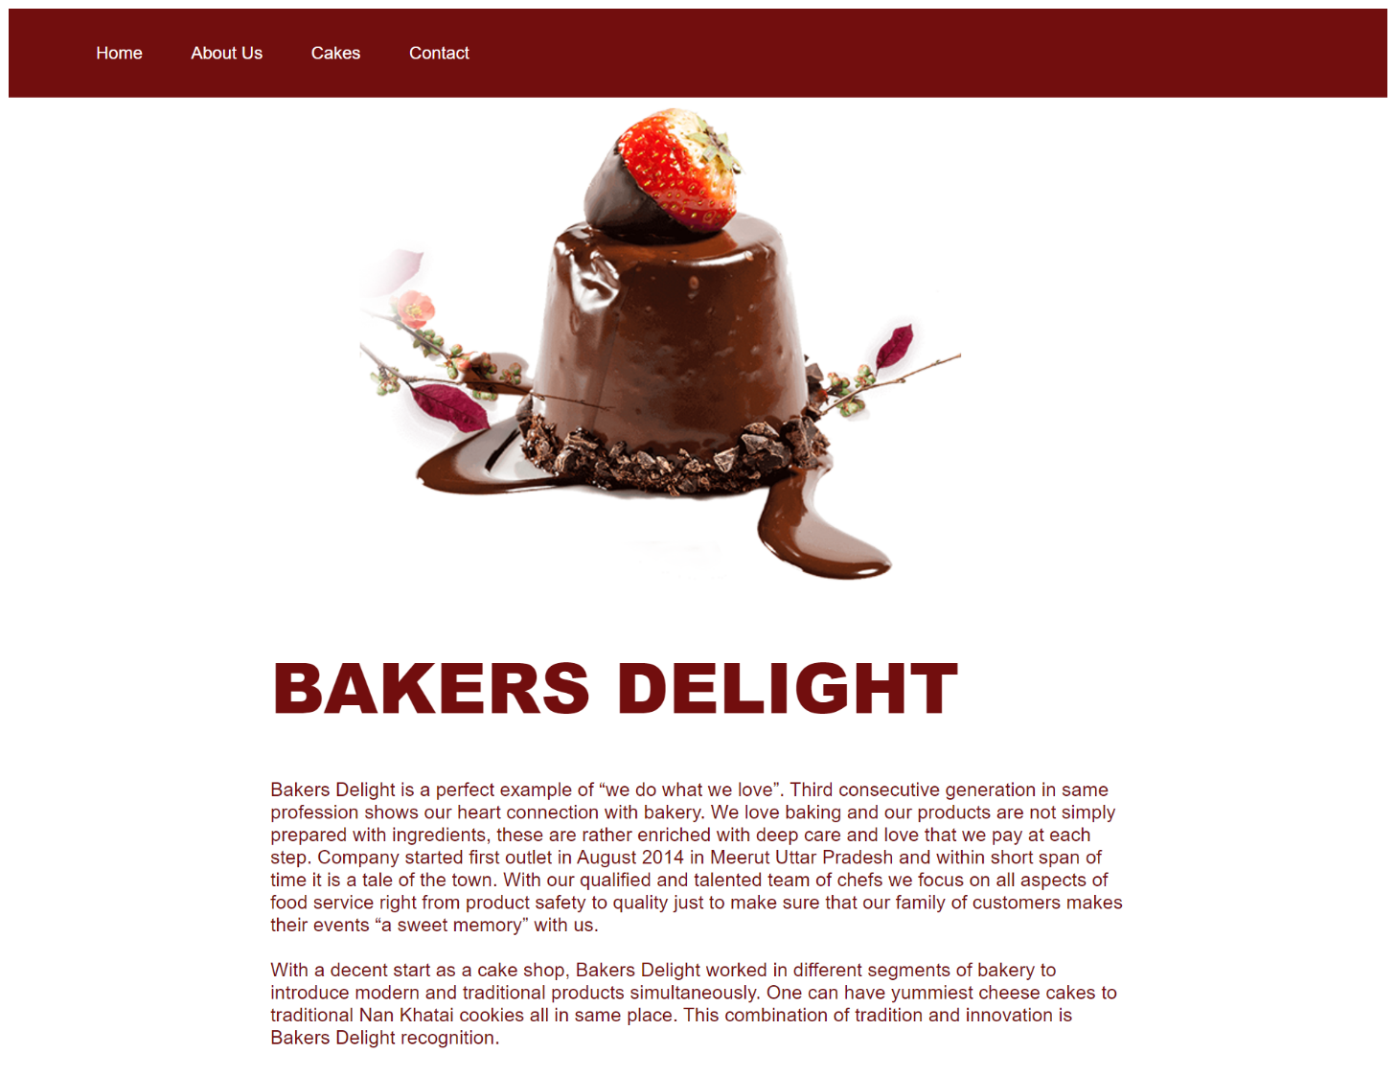

1. Cakes page

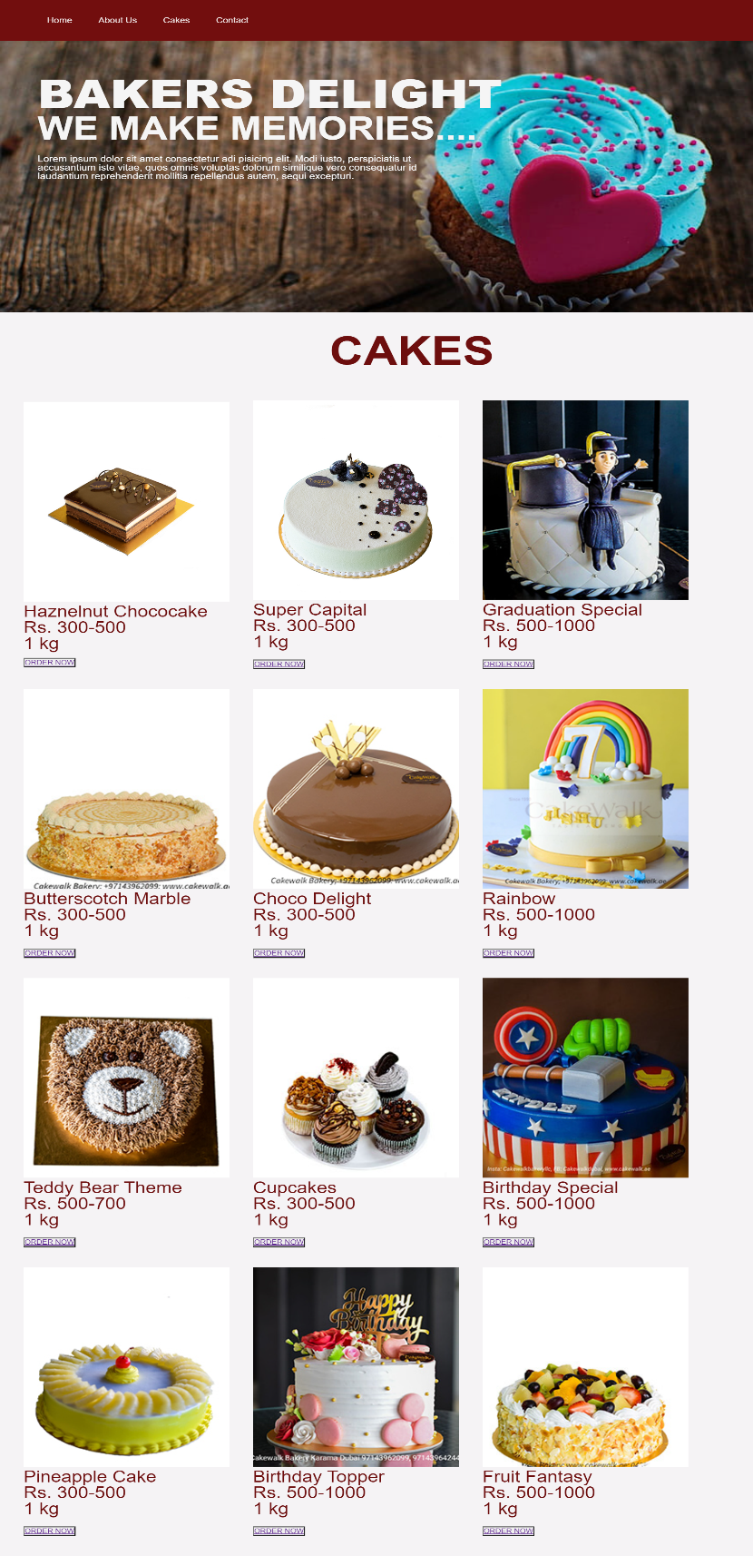

1. Contact Us page

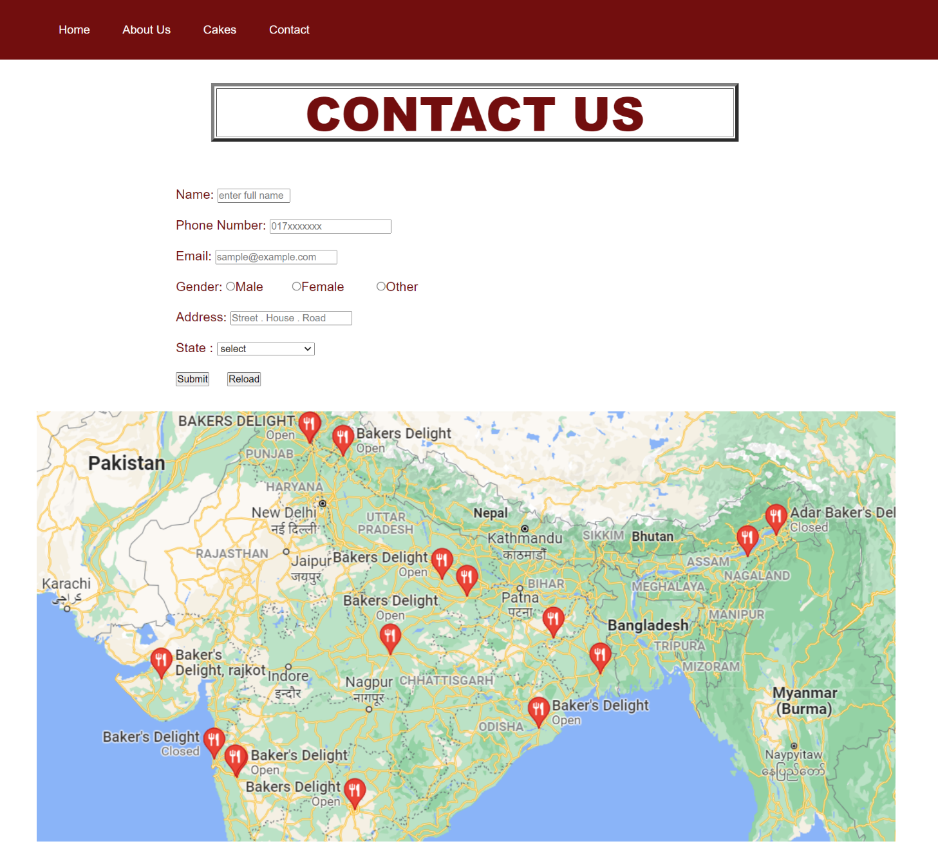

1. Thank-you page

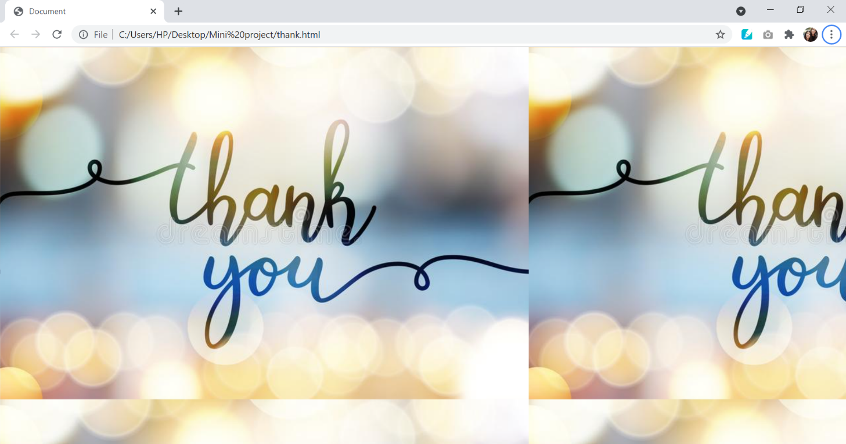

**IMPLEMENTATION CODE**

1. A) Code of Index page

<!DOCTYPE html>

<html lang="en">

<head>

    <meta charset="UTF-8">

    <meta http-equiv="X-UA-Compatible" content="IE=edge">

    <meta name="viewport" content="width=device-width, initial-scale=1.0">

    <link rel="stylesheet" href="style.css">

    <title>Cake Bakery</title>

</head>

<body>

    <section class="showcase">

        <header>

            <h2 class="logo">Cake Bakery</h2>

            <div class="toggle"></div>

        </header>

        <video src="cake.mp4" muted loop autoplay></video>

            <div class="overlay"></div>

            <div class="text">

                <h2>BAKERS DELIGHT</h2>

                <h3> We make memories....</h3>

                <p>Lorem ipsum dolor sit amet consectetur adi

                    pisicing elit. Modi iusto, perspiciatis ut

                    accusantium iste vitae, quos omnis voluptas dolorum

                     similique vero consequatur id laudantium reprehenderit

                     mollitia repellendus autem, sequi excepturi.</p>

            <a href="#" class="href">EXPLORE</a>

             </div>

             <ul class="social">

                <li><img src="facebook.png" width="50" alt=""></li>

                <li><img src="insta.png" width="50" alt=""></li>

                <li><img src="twitter.png" width="50" alt=""></li>

             </ul>

    </section>

    <div class="menu">

        <ul>

            <li><a href="home.html" >Home</a></li><br>

            <li><a href="about.html" >About Us</a></li><br>

            <li><a href="cake.html" >Cakes</a></li><br>

            <li><a href="contact.html" >Contact</a></li>

        </ul>

    </div>

    <script>

        const menuToggle = document.querySelector('.toggle')

        const showcase = document.querySelector('.showcase')

        menuToggle.addEventListener('click', () =>{

            menuToggle.classList.toggle('acitve')

            showcase.classList.toggle('active')

        })

    </script>

</body>

</html>

1. B) Stylesheet for Index page

@import url('https://fonts.googleapis.com/css2?family=Poppins:wght@200;300;400;500;600;700;800&display=swap');

*{

    box-sizing: border-box;

    margin: 0;

    padding: 0;

    font-family: 'Poppons', sans-serif;

}

.showcase{

    position: absolute;

    right: 0;

    width: 100%;

    min-height: 100vh;

    padding: 100px;

    display: flex;

    justify-content: space-between;

    align-items: center;

    background: #111;

    color:rgb(245, 243, 243);

    z-index: 2;

    transition: 0.5s;

}

.showcase.active{

    right:300px;

}

.showcase header{

    position: absolute;

    top: 0;

    left:0;

    width: 100%;

    padding: 40px 100px;

    display: flex;

    justify-content: space-between;

    align-items: center;

    z-index: 1000;

}

.logo{

    text-transform: uppercase;

    cursor: pointer;

}

.toggle{

    position: relative;

    width: 60px;

    height: 60px;

    background: url('menu.png');

    background-repeat: no-repeat;

    background-size: 100px;

    background-position: center;

    cursor: pointer;

}

.toggle.active {

    background: url('close.png');

    background-repeat: no-repeat;

    background-size: 25px;

    background-position: center;

}

.showcase video{

    position: absolute;

    top:0;

    left:0;

    width: 100%;

    height: 100%;

    object-fit: cover;

    opacity: 0.8;

}

.overlay{

    position: absolute;

    top: 0;

    left: 0;

    width: 100%;

    height: 100%;

    background: rgb(145, 143, 143);

    mix-blend-mode: overlay;}

.text{

    position: relative;

    z-index: 10;

}

.text h2{

    font-size: 5em;

    font-weight: 800;

    line-height: 1em;

    text-transform: uppercase;}

.text h3{

    font-size: 4em;

    font-weight: 00;

    line-height: 1em;

    text-transform: uppercase;

}

.text p{

    font-size: 1.1em;

    margin: 20px 0;

    font-weight: 400;

    max-width: 700px;}

.text a{

    display: inline-block;

    font-size: 1em;

    background: #fff;

    padding: 10px 30px;

    text-decoration: none;

    color:#111;

    margin-top: 10px;

    text-transform: uppercase;

    letter-spacing: 2px;

    transition: 0.2s;

}

.text a:hover{

    letter-spacing: 6px;}

.social{

    position: absolute;

    bottom: 20px;

    z-index: 10;

    display: flex;

    justify-content: center;

    align-items: center;}

.social li{

    list-style: none;

    padding-left: 10px;

}

.social li a{

    display: inline-block;

    filter: invert(1);

    margin-right: 20px;

    transform: scale(0.5);

    transition: 0.5s;

}

.social li a:hover{

    transform: scale(0.5) translateY(-15px);

}

.menu{

    position: absolute;

    top: 0;

    right: 0;

    width: 300px;

    height: 100%;

    display: flex;

    align-items: center;

    justify-content: center;

    background-color: rgb(83, 5, 5);

}

.menu ul{

    position: relative;

    list-style: none;}

.menu ul li a{

    text-decoration: none;

    font-size: 24px;

    color:rgb(247, 242, 242);

}

.menu ul li a:hover{

    color:rgb(145, 143, 143)

}

@media (max-width:798px){

    .showcase,

    .showcase header{

        padding: 40px;

}

.text h2{

        font-size: 3em;}

.text h3{

       font-size: 3em;}

}

1. A) Code of Home page
2. <!DOCTYPE html>
3. <html lang="en">
4. <head>
5. <meta charset="UTF-8">
6. <meta http-equiv="X-UA-Compatible" content="IE=edge">
7. <meta name="viewport" content="width=device-width, initial-scale=1.0">
8. <title>Home</title>
9. <link rel="stylesheet" href="style1.css">
10. </head>
11. <body>
12. <div class="navbar">
13. <nav>
14. <ul>
15. <li><a href="home.html">Home</a></li>
16. <li><a href="about.html">About Us</a></li>
17. <li><a href="cake.html">Cakes</a></li>
18. <li><a href="contact.html">Contact</a></li>
19. </ul>
20. </nav>
21. </div>
22. <div class="container">
23. <div class="overlay"></div>
24. <div class="text">
25. <h2>BAKERS DELIGHT</h2>
26. <h3> We make memories....</h3>
27. <p>Lorem ipsum dolor sit amet consectetur adi
28. pisicing elit. Modi iusto, perspiciatis ut
29. accusantium iste vitae, quos omnis voluptas dolorum
30. similique vero consequatur id laudantium reprehenderit
31. mollitia repellendus autem, sequi excepturi.</p>
32. </div>
33. </div>
34. <div class="content"><br><br>
35. <a href="about.html">
36. <div class="box">
37. <img src="about.jpg" alt="">
38. <div class="text1">
39. <h2>
40. About Us
41. </h2>
42. <p>Bakers Delight is a perfect example of “we do what we love”. Third consecutive generation in same profession shows our heart connection with bakery. We love baking and our products are not simply prepared with ingredients, these are rather enriched with deep care and love that we pay at each step. Company started first outlet in August 2014 in Meerut Uttar Pradesh and within short span of time it is a tale of the town.</p></div>
43. </div></a>
44. <br>
45. <a href="cake.html">
46. <div class="box">
47. <img src="c2.jfif" alt="">
48. <div class="text1">
49. <h2>
50. FRESH CAKES FOR CAKE LOVERS
51. </h2>
52. </div>
53. </div></a>
54. <br>
55. <a href="contact.html">
56. <div class="box">
57. <img src="contact.jpg" alt="">
58. <div class="text1">
59. <h2>
60. contact us
61. </h2>
62. <p>While we’re good with smoke signals, there are simpler ways for us to get in touch.”</p>
63. </div>
64. </div>
65. </a>
66. <br><br>
67. </div>
68. </body>
69. </html>
70. B) Stylesheet of Home page
71. @import url('https://fonts.googleapis.com/css2?family=Poppins:wght@200;300;400;500;600;700;800&display=swap');
72. *{
73. box-sizing: border-box;
74. margin: 0;
75. padding: 0;
76. font-family: 'Poppons', sans-serif;
77. background-attachment: fixed;
78. }
79. .container{
80. height:100vh;
81. width:100%;
82. background-image:url('c1.jfif');
83. background-position:center;
84. background-size: cover;
85. padding-left: 5%;
86. padding-right: 5%;
87. box-sizing: border-box;
88. position: relative;
89. }
90. .navbar{
91. width:100%;
92. height: 15vh;
93. margin:auto;
94. display:flex;
95. align-items: center;
96. background-color: rgb(114, 14, 14);
97. }
98. nav{
99. flex:1;
100. padding-left: 60px;}
101. nav ul li {
102. display: inline-block;
103. list-style: none;
104. margin: 0px 20px;}
105. nav ul li a{
106. text-decoration: none;
107. color: rgb(243, 235, 235);}
108. .overlay{
109. position: absolute;
110. top: 0;
111. left: 0;
112. width: 100%;
113. height: 100%;
114. background: rgb(145, 143, 143);
115. mix-blend-mode: overlay;}
116. .text{
117. margin-top: 4em;
118. position: absolute;
119. z-index: 10;
120. color: whitesmoke;}
121. .text h2{
122. font-size: 5em;
123. font-weight: 800;
124. line-height: 1em;
125. text-transform: uppercase;
126. }
127. .text h3{
128. font-size: 4em;
129. font-weight: 00;
130. line-height: 1em;
131. text-transform: uppercase;
132. }
133. .text p{
134. font-size: 1.1em;
135. margin: 20px 0;
136. font-weight: 400;
137. max-width: 700px;
138. }
139. .content{
140. margin:auto;
141. background-color: rgb(77, 74, 77);
142. }
143. .box{
144. position: center;
145. margin:auto;
146. width: 60%;
147. height: 60vh;
148. background-color:thistle;
149. border-radius: 20px;}
150. .box img{
151. width: 200px;
152. height: 200px;
153. position: absolute;
154. margin-top: 6em;
155. margin-left: 2em;
156. border-radius: 1em;
157. border-bottom-left-radius: 3em;
158. border-top-right-radius: 3em;
159. }
160. .text1{
161. margin-left: 3em;
162. z-index: 8;
163. color: rgb(109, 14, 14);}
164. .text1 h2{
165. font-size: 5em;
166. font-weight: 700;
167. line-height: 1em;
168. margin-left: 3em;
169. margin-top: 1em;
170. text-transform: uppercase;
171. }
172. .text1 p{
173. font-size: 1.1em;
174. margin: 20px 0;
175. font-weight: 400;
176. max-width: 700px;
177. margin-left: 12em;
178. margin-top:2em;
179. }

3. A) Code of About us

<!DOCTYPE html>

<html lang="en">

<head>

    <meta charset="UTF-8">

    <meta http-equiv="X-UA-Compatible" content="IE=edge">

    <meta name="viewport" content="width=device-width, initial-scale=1.0">

    <link rel="stylesheet" href="style2.css">

    <title>About Us</title>

</head>

<body>

    <header>

    <div class="navbar">

        <nav>

            <ul>

                <li><a href="home.html">Home</a></li>

                <li><a href="about.html">About Us</a></li>

                <li><a href="cake.html">Cakes</a></li>

                <li><a href="contact.html">Contact</a></li>

            </ul>

        </nav>

    </div>

</header>

    <table>

        <tr>

            <td>

                <img src="c3.png" alt="">

            </td>

        </tr>

    </table>

    <div class="text">

   <h2>BAKERS DELIGHT</h2>

<p>Bakers Delight is a perfect example of “we do what we love”. Third consecutive generation in same profession shows our heart connection with bakery. We love baking and our products are not simply prepared with ingredients, these are rather enriched with deep care and love that we pay at each step. Company started first outlet in August 2014 in Meerut Uttar Pradesh and within short span of time it is a tale of the town. With our qualified and talented team of chefs we focus on all aspects of food service right from product safety to quality just to make sure that our family of customers makes their events “a sweet memory” with us.<br><br>

With a decent start as a cake shop, Bakers Delight worked in different segments of bakery to introduce modern and traditional products simultaneously. One can have yummiest cheese cakes to traditional Nan Khatai cookies all in same place. This combination of tradition and innovation is Bakers Delight recognition.</p></div>

</body>

</html>

3. B) Stylesheet of About Us

@import url('https://fonts.googleapis.com/css2?family=Poppins:wght@200;300;400;500;600;700;800&display=swap');

*{

    box-sizing: border-box;

    padding: 0;

    font-family: 'Poppons', sans-serif;}

.navbar{

    width:100%;

    height: 15vh;

    margin:auto;

    display:flex;

    align-items: center;

    background-color: rgb(114, 14, 14);}

nav{

    flex:1;

    padding-left: 60px;}

nav ul li {

    display: inline-block;

    list-style: none;

    margin: 0px 20px;}

nav ul li a{

    text-decoration: none;

    color: white;}

table{

    margin-left: 20em;

    margin-right: 20em;}

.text{

    color: rgb(114, 14, 14);

    margin-left: 15em;

    margin-right: 15em;}

.text h2{

    font-size: 4em;

    font-weight: 800;

    line-height: 1em;

    text-transform: uppercase;}

.text p{

    font-size: 1.1em;

    font-weight: 400;

    max-width: 800px;}

4. A) Code of Cakes page

<!DOCTYPE html>

<html lang="en">

<head>

    <meta charset="UTF-8">

    <meta http-equiv="X-UA-Compatible" content="IE=edge">

    <meta name="viewport" content="width=device-width, initial-scale=1.0">

    <link rel="stylesheet" href="style4.css">

    <title>Cake</title>

</head>

<body>

    <header></header>

    <div class="navbar">

        <nav>

            <ul>

                <li><a href="home.html">Home</a></li>

                <li><a href="about.html">About Us</a></li>

                <li><a href="cake.html">Cakes</a></li>

                <li><a href="contact.html">Contact</a></li>

            </ul>

        </nav>

    </div>

</header>

<div class="container">

    <div class="overlay"></div>

    <div class="text">

        <h2>BAKERS DELIGHT</h2>

        <h3> We make memories....</h3>

        <p>Lorem ipsum dolor sit amet consectetur adi

            pisicing elit. Modi iusto, perspiciatis ut

            accusantium iste vitae, quos omnis voluptas dolorum

             similique vero consequatur id laudantium reprehenderit

             mollitia repellendus autem, sequi excepturi.</p>

    </div>

    </div>

    <div class="content"><br><br>

    <div class="text1">

        <h2>

            CAKES

        </h2>

    </div>

    <br>

    <table cellspacing="40">

        <tr>

        <td><img src="d1.jpg"><br><p> Haznelnut Chococake<BR>Rs. 300-500 <br> 1 kg <br>

        <button><a href="contact.html" class="href">ORDER NOW</a></button></p> </td>

        <td><img src="d2.jpg"><br><p> Super Capital <br>Rs. 300-500 <br> 1 kg</p><br>

        <button><a href="contact.html" class="href">ORDER NOW</a></button> </td>

        <td><img src="d3.jpg"><br><p> Graduation Special <br>Rs. 500-1000 <br> 1 kg</p><br>

        <button><a href="contact.html" class="href">ORDER NOW</a></button></td>

    </tr>

    <tr>

        <td><img src="d4.jpg"><br><p> Butterscotch Marble <br>Rs. 300-500 <br> 1 kg</p><br>

            <button><a href="contact.html" class="href">ORDER NOW</a></button> </td>

        <td><img src="d5.jpeg"><br><p> Choco Delight <br> Rs. 300-500 <br> 1 kg</p><br>

            <button><a href="contact.html" class="href">ORDER NOW</a></button> </td>

        <td><img src="d6.jpg"><br><p> Rainbow <br> Rs. 500-1000 <br> 1 kg</p><br>

            <button><a href="contact.html" class="href">ORDER NOW</a></button> </td>

    </tr>

    <tr>

        <td><img src="d7.jpg"><br><p> Teddy Bear Theme <br>Rs. 500-700 <br> 1 kg</p><br>

            <button><a href="contact.html" class="href">ORDER NOW</a></button> </td>

        <td><img src="d8.jpg"><br><p> Cupcakes <br> Rs. 300-500 <br> 1 kg</p><br>

            <button><a href="contact.html" class="href">ORDER NOW</a></button> </td>

        <td><img src="d9.jpg"><br><p> Birthday Special <br> Rs. 500-1000 <br> 1 kg</p><br>

            <button><a href="contact.html" class="href">ORDER NOW</a></button> </td>

    </tr>

    <tr>

        <td><img src="d10.jpg"><br><p> Pineapple Cake <br>Rs. 300-500 <br> 1 kg</p> <br>

            <button><a href="contact.html" class="href">ORDER NOW</a></button></td>

        <td><img src="d11.jpg"><br><p> Birthday Topper <br> Rs. 500-1000 <br> 1 kg</p> <br>

            <button><a href="contact.html" class="href">ORDER NOW</a></button></td>

        <td><img src="d12.jpg"><br><p> Fruit Fantasy <br> Rs. 500-1000 <br> 1 kg</p><br>

            <button><a href="contact.html" class="href">ORDER NOW</a></button> </td>

    </tr></table> </div></body></html>

4. B) Stylesheet of Cakes page

@import url('https://fonts.googleapis.com/css2?family=Poppins:wght@200;300;400;500;600;700;800&display=swap');

*{

    box-sizing: border-box;

    margin: 0;

    padding: 0;

    font-family: 'Poppons', sans-serif;

    background-attachment: fixed;}

.container{

    height:100vh;

    width:100%;

    background-image: url('c6.jpg');

    background-position:center;

    background-size: cover;

    padding-left: 5%;

    padding-right: 5%;

    box-sizing: border-box;

    position: relative;}

.navbar{

    width:100%;

    height: 15vh;

    margin:auto;

    display:flex;

    align-items: center;

    background-color: rgb(114, 14, 14);}

nav{

    flex:1;

    padding-left: 60px;}

nav ul li {

    display: inline-block;

    list-style: none;

    margin: 0px 20px;}

nav ul li a{

    text-decoration: none;

    color: rgb(243, 235, 235);}

.overlay{

    position: absolute;

    top: 0;

    left: 0;

    width: 100%;

    height: 100%;

    background: rgb(145, 143, 143);

    mix-blend-mode: overlay;}

.text{

    margin-top: 4em;

    position: absolute;

    z-index: 10;

    color: whitesmoke;}

.text h2{

    font-size: 5em;

    font-weight: 800;

    line-height: 1em;

    text-transform: uppercase;}

.text h3{

    font-size: 4em;

    font-weight: 00;

    line-height: 1em;

    text-transform: uppercase;}

.text p{

    font-size: 1.1em;

    margin: 20px 0;

    font-weight: 400;

    max-width: 700px;

    color: whitesmoke;}

.content{

    margin:auto;

    background-color: rgb(245, 243, 245);}

.box{

    position: center;

    margin:auto;

    width: 60%;

    height: 60vh;

    background-color:thistle;

    border-radius: 20px;}

.box img{

    width: 200px;

    height: 200px;

    position: absolute;

    margin-top: 6em;

    margin-left: 2em;

    border-radius: 1em;

    border-bottom-left-radius: 3em;

    border-top-right-radius: 3em;}

.text1{

    margin-left: 20em;

    margin-right: 20em;

    color: rgb(109, 14, 14);}

.text1 h2{

    font-size: 5em;

    font-weight: 700;

    line-height: 1em;

    margin-left: 3em;

    text-transform: uppercase;}

p{

    font-size: 2em;

    font-weight: 400;

    max-width: 700px;

    line-height: 1em;

    color: rgb(109, 14, 14) ;}

table img{

    width:350px;

    height: 400px;}

5. A) Code of Contact Us page

<!DOCTYPE html>

<html lang="en">

<head>

    <meta charset="UTF-8">

    <meta http-equiv="X-UA-Compatible" content="IE=edge">

    <meta name="viewport" content="width=device-width, initial-scale=1.0">

    <link rel="stylesheet" href="style3.css">

    <title>Contact</title>

</head>

<body>

    <header>

        <div class="navbar">

            <nav>

                <ul>

                    <li><a href="home.html">Home</a></li>

                    <li><a href="about.html">About Us</a></li>

                    <li><a href="cake.html">Cakes</a></li>

                    <li><a href="contact.html">Contact</a></li>

                </ul>

            </nav>

        </div>

    </header>

    <div class="text">

    <table align="center" border="5" cellpadding="50" width="60%">

    <th>

    <h2> CONTACT US </h2>

    </th>

    </table>

    <p>

    <font face="algerian"><br><br><br>

    Name:                  <input type="text" placeholder="enter full name" size="10"><BR><br>

    Phone Number:   <input type="number" placeholder="017xxxxxxx" maxlength="10" ><br><br>

    Email:                  <input type="text" placeholder="sample@example.com" ><BR><br>

    Gender:              <input type="radio" name="Male" value="Male" >Male&nbsp &nbsp &nbsp &nbsp

    <input type="radio" name="Female" value="Female" >Female &nbsp &nbsp &nbsp &nbsp

     <input type="radio" name="Other" value="Other" >Other <br><br>

    Address:              <input type="address" placeholder="Street . House . Road" size="20"><BR><br>

        State :     <select name="subject">

         <option selected>select</option>

         <option>Andhra Pradesh</option>

         <option>Goa</option>

         <option>Uttar Pradesh</option>

         <option>Himachal Pradesh</option>

         </SELECT> <br><br>

         <a href="thank.html" class="href"><button type="submit">Submit</button></a> &nbsp &nbsp

         <a href="contact.html" class="href"><button type="reload"> Reload</button></a>

        </p>

          </font>

    </div>

    <table>

        <tr>

            <td>

                <a href="https://www.google.com/search?q=bakers%20delight%20location%20o

                n%20map%20india&rlz=1C1GCEA_enIN968IN968&oq=bakers+&aqs=chrome.0.69i59l3j69i57

                j69i59j69i60l2j69i61.2422j1j7&sourceid=chrome&ie=UTF-8&tbs=lf:1,lf_ui:4&tbm=lcl

                &sxsrf=AOaemvJsYEL2BwcqBoTlzzWQHWUFyDFOKA:1634658922830&rflfq=1&num=10&rldimm=9

                987316400940350827&lqi=CiRiYWtlcnMgZGVsaWdodCBsb2NhdGlvbiBvbiBtYXAgaW5kaWEiA4gBA

                Uik_fuVhK2AgAhaKRAAEAEQAhADGAAYASIbYmFrZXJzIGRlbGlnaHQgb24gbWFwIGluZGlhkgEGYmFrZX

                J5qgEWEAEqEiIOYmFrZXJzIGRlbGlnaHQoAA&ved=2ahUKEwiF7LGD69bzAhWWfn0KHUNtAQcQvS56BAg

                KEDE&rlst=f#rlfi=hd:;si:9987316400940350827,l,CiRiYWtlcnMgZGVsaWdodCBsb2NhdGlvbiB

                vbiBtYXAgaW5kaWEiA4gBAUik_fuVhK2AgAhaKRAAEAEQAhADGAAYASIbYmFrZXJzIGRlbGlnaHQgb24g

                bWFwIGluZGlhkgEGYmFrZXJ5qgEWEAEqEiIOYmFrZXJzIGRlbGlnaHQoAA;mv:[[33.8062852,83.546

                17569999999],[10.4123057,73.17455679999999]];tbs:lrf:!1m4!1u3!2m2!3m1!1e1!1m4!1u16!

                2m2!16m1!1e1!1m4!1u16!2m2!16m1!1e2!2m1!1e16!2m1!1e3!3sIAE,lf:1,lf_ui:4" class="href">

                    <img src="map.png" alt=""></a>

            </td>

        </tr>

    </table>

</body>

</html>

5. B) Stylesheet of Contact Us page

@import url('https://fonts.googleapis.com/css2?family=Poppins:wght@200;300;400;500;600;700;800&display=swap');

*{

    box-sizing: border-box;

    padding: 0;

    font-family: 'Poppons', sans-serif;

    margin:0;}

.navbar{

    width:100%;

    height: 15vh;

    margin:auto;

    display:flex;

    align-items: center;

    background-color: rgb(114, 14, 14);}

nav{

    flex:1;

    padding-left: 60px;}

nav ul li {

    display: inline-block;

    list-style: none;

    margin: 0px 20px;}

nav ul li a{

    text-decoration: none;

    color: white;}

table{

    width: 90%;

    margin-top: 2em;

    margin-left: 3em;}

.text{

    color: rgb(114, 14, 14);

    margin-left: 15em;

    margin-right: 15em;}

.text h2{

    font-size: 4em;

    font-weight: 800;

    line-height: 1em;

    text-transform: uppercase;}

.text p{

    font-size: 1.1em;

    font-weight: 400;

    max-width: 800px;}

6. Code of Thank you page

1. <!DOCTYPE html>
2. <html lang="en">
3. <head>
4. <meta charset="UTF-8">
5. <meta http-equiv="X-UA-Compatible" content="IE=edge">
6. <meta name="viewport" content="width=device-width, initial-scale=1.0">
7. <title>Document</title>
8. </head>
9. <body background="t1.jpeg">
11. </body>
12. </html>